

**Financial Analysis,**

**Pricing Strategy, Forecasting.**

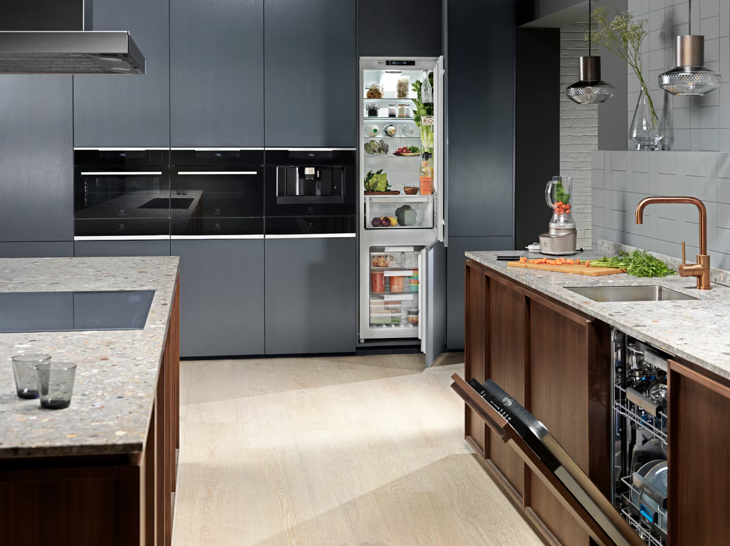

**Writer: Qianqian Yang**

**Valuation Report**

**Company name: AB Electrolux**

**Exchange: Nasdaq Nordic**

**Ticker symbol: ELUX B**

**Sector: Consumer Goods**

**Industry: Household Appliances**

**Recommendation: Hold**

**Current price (as of 20/03/2024): 91.20 SEK**

**Target price: + 2.82%**

1. **Company and Industry Introduction**

AB Electrolux manufactures and sells household appliances globally. It was founded in 1901 with headquarters in Stockholm, Sweden and has expanded throughout Europe, North America, Latin America and Asia-Pacific. The company offers a diverse product portfolio ranging from kitchen appliances, laundry solutions, floor-care equipment for consumers, and specialised offerings for professional users like commercial kitchens and laundries.

AB Electrolux maintains a strong global position for its innovation, quality, and reliability. The main product lines of AB Electrolux are kitchen appliances (62%), laundry products (30%) and well-being products (8%) **(Exhibit 1).** The company's net sales by geography in 2023 were: 34% in Europe; 22% in Latin America; 34% in North America; and 11% in Asia-Pacific. **(Exhibit 2)**

Overall, the home appliance industry was negatively impacted by high global inflation, rising interest rates, and geopolitical tensions, which influence both industry dynamics and individual company performance. The industry has seen weaker market demand, and instead growing demand for energy-efficient and smart appliances. In such an increasingly competitive industry, the company faces challenges from other competitors such as Whirlpool, Dyson, and Bosch-Siemens, etc. It has grown on continuous technological improvement in recent years, driven by substantial investments in R&D to enhance customers’ experience and improve energy efficiency. Investments in research and development to meet consumer demand for innovative products contribute to operational expenses. Compliance with environmental regulations necessitates sustainable manufacturing practices, potentially increasing production costs. Also, the increasing global operations of household appliance companies have led to increased opportunities to enter new markets and lower costs.

The AB Electrolux share is quoted and traded on Nasdaq Stockholm. In 2023, the company’s share price was down by 30% and the market capitalisation was around SEK 24.7bn at the end of the year.

1. **Financial statement and accounting analysis**

To calculate Invested Capital (IC) (**Exhibit 3)** and Net Operating Profit After Tax (NOPAT) **(Exhibit 4)**, we need to identify the operating and non-operating items.

For cash and equivalents, only 2% are classified as operating items, representing liquidity necessary for day-to-day operations. Since accounts receivable arise from operational sales transactions, they are also considered operating items. Inventories are essential for a manufacturing company's operations and are therefore classified as operating items. Prepaid expenses are paid in advance related to ongoing operations and are classified as operating items. With the manufacturing operations, PPE is treated as an operating item since it is an essential infrastructure for the company. Although deferred tax assets are related to tax management, these assets arise from operational activities and are therefore considered operating items. Deferred charges and other long-term assets are relatively small and related to ongoing operations and, therefore are classified as operating items.

In terms of liabilities, accounts payable and accrued expenses arise from ongoing operational obligations and are therefore classified as operating items. Long-term debt, leases and taxes payable represent expenses due within the operating cycle and are considered operating items. Pension & other post-retirement benefits are directly related to employee compensation, which is essential for sustaining operations.

Short-term and long-term investments are not considered operating expenses. As the manufacturing company, goodwill and other intangible asset values are not realized until the sale of the company/assets, they are considered non-operating.

1. **Firm performance and Peer comparison**

During 2019 to 2023, the historical revenue growth lies between -4.4% to 8.3%. The 5-year compounded rate is 1.6%, while the company’s profitable growth target annually is at 4% **(Exhibit 5)**

***Organic growth***: In 2021, Electrolux achieved the highest organic growth rate (14.2 percent) in five years. The main reason for this was the sharp increase in market demand during the year. Demand drives prices, and the price increases the revenue. In addition, Electrolux's commitment to delivering sustainable consumer experience innovation contributed strongly to the result. An attractive product offering, delivered under well-established brands, continued to generate an improved mix through selling more innovative premium products. Aftermarket sales, one of the Group's focus areas, continued to grow 7% of total sales for the year, following the high organic growth of the Group.

***Acquired growth:*** The acquisition accounted for 2023 (0%), 2022 (1%), 2021(0.2%), 2020(0.1%), and 2019 (0%), which indicates that acquired growth is not the main driver of revenue growth in these five years

Electrolux is in the final stage of executing its SEK 8bn re-engineering investments, which focus on modularization and automation of selected production facilities in Europe and the Americas. Now in its ramp-up phase, the investment initiative will significantly leverage global scale by deploying Group-wide technologies and product architecture.

We use Haier Smart Home, Arcelik AS and Whirlpool as peer group companies. Market leader Haier Smart Home holds the largest market share at 13.1% of the household appliance industry, followed by Whirlpool at 7.1% and Electrolux at 4.8%. In addition, its competitor, Arcelik AS, holds smaller shares at 3.2% **(Exhibit 6)**. We evaluate the performance of these companies from the following perspectives: revenue growth, capital and cost efficiency, and profitability **(Exhibit 7)**.

Regarding revenue growth, Electrolux experienced modest increases in revenue growth in 2019 and 2021, ranging from 3.05% to 8.34%, indicating positive trends. However, after 2021, a decline occurred, from 2.54% to -0.32%. Compared to its peers like Arcelik AS, Haier, and Whirlpool Corp, Electrolux's revenue growth rate remained relatively stable.

Electrolux's five-year average ROIC is -0.05, with its ROIC turning negative in 2022 and 2023 **(Exhibit 8)**. This decline is primarily attributed to Electrolux's COGS/revenue ratio, which reached its peak at 0.87 during these years, indicating poorer cost efficiency compared to its peers. Notably, Arcelik outperforms due to a significantly higher capital efficiency ratio (5-year average revenue/IC: 24.38). While Electrolux's ROIC slightly outperformed Whirlpool from 2018 to 2021, in the last two years, it lags behind Whirlpool. Haier consistently exhibits the lowest ROIC due to its lower capital efficiency ratio (-6.28). **(Exhibit 7)**.

Regarding capital efficiency, from 2019 to 2023, Electrolux’s capital efficiency ratio ranged from 5.53 to 17.63. While Electrolux’s five-year average surpasses that of Haier and Whirlpool, it remains below Arcelik AS. However, its capital efficiency ratio began declining after 2022. **(Exhibit 7)**.

In 2019, Electrolux’s profitability peaked at 0.04 within five years, albeit still lower than other companies. After 2022, due to deteriorating cost efficiency and a downward trend in capital efficiency in the last two years, Electrolux’s profitability (measured by NOPAT/revenue) dropped from 0.04 in 2019 to -0.06 in 2023. **(Exhibit 7)**.

1. **Key driver forecast and continuing value forecast**

For forecasting purposes, we have used a 7-year explicit period given the following considerations:

1. The household appliances market has a mix of cyclical and non-cyclical features, making it susceptible to business cycles in a moderate manner, motivating us to consider 7 years as an approximate medium term in the market.

2. The company has set out a strategy for profitable growth over a business cycle, which includes 4 main targets:

• Operating margin of at least 6%.

• Return on net assets >20%.

• Sales growth of at least 4% annually.

• Capital turnover rate of at least 4.

Given the above considerations, we have formulated three different scenarios: best case, worst case, and normal case **(Exhibit 11)**. For the expected case scenario, we have devised a forecasting metric that computes the average of the past 5 years on a rolling basis and adds the company’s share of the expected industry CAGR growth rate to it. This assumption allows the growth rate of the company to reach a stable rate (1.19%) within 7 years, which remains below the industry growth rate of 5.7% CAGR for 2024 to 2029, which translates to 1.1% annual growth. We also assume that 2024(E) revenue growth follows a downward trend, in sync with the market expectations of a prolonged energy crisis and weakening demand. Given that the Cost of goods sold is a key driver in the revenue share, we make an important assumption that the share of COGS per revenue is close to the 2020-21 level. In this case, we figure that the operating margin maintains a 2% growth in the explicit forecast period. This technique allows for the Free Cash Flow to reflect the cyclicality of the historical period while maintaining sustained growth.

Under the best-case scenario, we assume that the company can achieve at least 3 of its performance goals: a net sales average growth of 4%, an operating margin maintaining 6% over the business cycle, and the cost of sales reduced to 0.75. In this case, we forecast that the company will improve from the 2022-23 growth rate slump, to reach the industry average growth rate within 7 years.

Under the worst-case scenario, we assume that the firm is not able to achieve any of its profitability goals and continues to follow the loss pattern of 2022 and 2023. Here, we maintain the same revenue growth rate as the normal case scenario, but we fix the share of cost of goods sold per revenue to the 2023 level.

In all the cases above, a major consideration we allow for is that the level of debt is assumed to grow at the 2023 rate in the explicit forecast period and the interest expenses are scaled to the prior year’s debts. In addition, the pension expenses are forecasted to trend toward zero using an exponential decay factor of 0.78. Regarding deferred taxes, the parent company reported that these assets mainly relate to the unused tax losses carried forward, restructuring provisions and pensions.

In essence, we find that the expected case scenario provides a realistic prediction of an improved, yet below target, operating margin and a pre-2022 level of ROIC. Using the computed WACC and the predicted steady-state growth rate of 0.019, we estimate an enterprise value of 67,666.38. In the best-case scenario, the operating margin reaches the target of 6% and an average ROIC level of 0.5 (indicative of the highest efficiency). Using the computed WACC and the predicted growth rate of 0.04, we estimate an enterprise value of 28267640. In the worst-case scenario, where the company fails to reach any of its targets and is being dragged down by the macroeconomic conditions, the operating margin continues to follow the 2023 level of -5% and an average ROIC of -0.6.

1. **Cost of capital**

To determine the cost of equity, we used the CAPM model and chose the bottom-up approach for the reason that this approach uses industry, rather than company-specific beta to capture operating risk. Thus, it helps to reduce the noise that may arise during the estimation of beta. First, we estimate levered betas for peers (Whirlpool; Arcelik; Haier) and Electrolux, specifically by doing regression analyses on daily stock returns and market returns between 2019 and 2023. After that, we unlevered these betas by using the debt/equity ratio of each company. Then we averaged the unlevered betas of the five companies to obtain the operating beta. Finally, we obtained the relevered data (0.6) **(Exhibit 9)**. As for the risk-free rate, we used a synthetic one of 4% and an equity premium of 5% suggested in the KGW 2020 book. The cost of equity was estimated at 7%.

Regarding the cost of debt, we use a credit rating approach to determine the yield spread **(Exhibit 10)**. Based on S&P Issuer Credit Rating, Electrolux is rated as a BBB firm with a 1.6132% probability of default. Since the market cap is larger than 5 billion, the yield spread of Electrolux should be 1.47%., which added back to the synthetic risk-free rate previously discussed of 4%, yields a 5.47% cost of debt.

Regarding the capital structure, from 2019 to 2021, the debt/equity ratio has been showing a slight steady increase and a sharp increase from 2021 to 2023, so we chose the average debt-equity ratio (176.89%) for these five years to measure the capital structure of Electrolux. Finally, we calculate the cost of capital, which is 0.054 approximately.

1. **DCF calculation and continuing value**

We preferred the FCFF model of DCF over FCFE and Dividend Discount Model due to the unstable leverage ratio of Electrolux and the fluctuating growth rates of the company during the historical period. The new net debt acquired by the company in the recent past has more than doubled, rendering the use of equity-based approach inadequate. Since, the debt payment and leverage are not factored in the cash flow and since the cost of capital is not changing exponentially over the historical period, we used firm valuation method. Since the company experienced uncertain and volatile earnings, forecasting future dividends was challenging. In addition, the DDM ignores other cash flows which are crucial sources of value creation for a manufacturing company like Electrolux. For the three scenarios, we used the respective growth rates and our computed WACC and obtained the following results **(Exhibit 12)**.

In the normal case, the present value of the cash flows during the entire valuation period is computed to be 7,137, while in the best-case scenarios, the present value of cash flows reaches 434,181 and in the worst case, it reaches -249,467. Thus, under normal conditions and the expected growth rate, we expect the company to generate positive (but insignificant) cash flows over the valuation period. In the best-case scenario, the company has a significantly higher valuation compared to normal case, reflecting the optimistic assumptions of the revenue growth, strengthening macroeconomic conditions, and other value drivers. In the worst-case scenario, under adverse conditions in the market and the company operation, Electrolux may not generate sufficient cash flows suggesting a risk of value destruction.

**7. Market-based valuation**

We select Haier Smart Home, Arcelik AS, and Whirlpool as the most relevant peers for Electrolux to conduct market-based valuation. This decision is based on their comparable growth rates, industry relevance, and similar risk profiles.

The typical forward-looking multiples are as follows: P/E, P/B, EV/EBITA. As we focused on FCFF, we chose to adopt the EV/EBITA ratio to forecast one-year forward enterprise value. EV/EBITA ratio is a comprehensive measure of a company’s operating performance.

Since our firms vary in capital structure, growth and investment rate, we try using multiple regressions to arrive at a controlled estimate for the EV/EBITA ratio. The key determinants of the ratio include growth rate, leverage condition (debt/equity ratio) and depreciation and amortization for the past five years. Firstly, we run the regression for each firm to analyze the relative importance of determinants for individual companies. Then, we pool data together and run the regression to mimic the industry condition and gain the relative importance of each determinant on the EV/EBITA ratio for the whole industry. We can see that the R-square of the individual company is high, but the industry R-square is low **(Exhibit 13)**, which might be due to the significant difference between the peers and Electrolux.

By inputting the data of determinants into the regression, we found out that the actual EV/EBITA for Electrolux (7.08) is lower than the predicted EV/EBITA(6.5), which indicates that Electrolux is overvalued **(Exhibit 14)**.

We have forecasted the one-year forward EBITA under three scenarios: best, worst, and normal. By multiplying the predicted EV/EBITA ratios by the estimated one-year forward EBITAs, we obtain the estimated one-year forward enterprise values for each scenario. In the best scenario, the enterprise value is projected to be 56,924.54 SEK. In the normal scenario, it is estimated at 24,392.51 SEK. In the worst scenario, the enterprise value could potentially be -58,089.04 SEK **(Exhibit 15)**.

**8. Conclusion**

Despite being a prominent player in the household appliance industry, Electrolux's overall performance has not been promising, as evidenced by its declining ROIC and insignificant NOPAT. This downward trend in financial metrics indicates significant challenges for the company's prospects.

This underperformance has been reflected in its share value, which has seen a significant decline over the past five years **(Exhibit 16)**. In 2018, the company’s share price was roughly above 230 SEK per share and gradually declined over time to 91.50 SEK during the evaluated period. This alignment with our assumption about the company's performance reinforces our concerns regarding Electrolux's future outlook.

**Appendix**

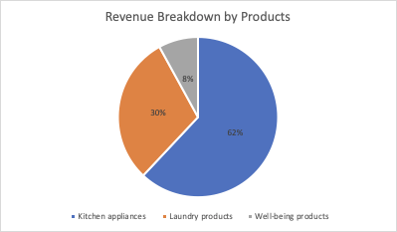

***Exhibit 1:*** *Revenue Breakdown by Products*

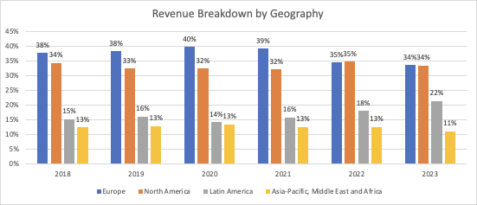

***Exhibit 2:*** *Revenue Breakdown by Geography*

|  |  |  |  |  |  |  |
| --- | --- | --- | --- | --- | --- | --- |
| **Year** | **2018** | **2019** | **2020** | **2021** | **2022** | **2023** |
| **Operating Asset** |  |  |  |  |  |  |
| Cash and equivalents | 233.94 | 216.14 | 403.92 | 218.46 | 351.18 | 306.62 |
| Accounts Receivable | 21,482.00 | 20,847.00 | 19,944.00 | 23,110.00 | 21,487.00 | 22,247.00 |
| Other Receivables | 3,535.00 | 4,304.00 | 3,733.00 | 4,176.00 | 4,946.00 | 4,130.00 |
| Inventory | 16,750.00 | 16,194.00 | 13,213.00 | 20,478.00 | 24,374.00 | 19,965.00 |
| Prepaid expenses | 1,710.00 | 1,074.00 | 1,007.00 | 1,415.00 | 1,360.00 | 1,347.00 |
| Other Current Assets | 140.00 | 8,226.00 | 134.00 | 204.00 | 100.00 | 167.00 |
| Net Property, Plant Equipment | 21,088.00 | 24,614.00 | 22,803.00 | 28,193.00 | 33,782.00 | 33,067.00 |
| Deferred charges | 1,026.00 | 1,278.00 | 1,294.00 | 1,596.00 | 2,156.00 | 2,138.00 |
| Other long term assets | 1,485.00 | 2,529.00 | 2,150.00 | 2,366.00 | 3,067.00 | 3,124.00 |
| Total | 67,449.94 | 79,282.14 | 64,681.92 | 81,756.46 | 91,623.18 | 86,491.62 |
|  |  |  |  |  |  |  |
| **Operating Liability** |  |  |  |  |  |  |
| Accounts payable | 34,443.00 | 33,892.00 | 31,306.00 | 38,182.00 | 38,357.00 | 36,402.00 |
| Accrued expenses | 9,161.00 | 7,738.00 | 8,643.00 | 9,308.00 | 8,022.00 | 7,711.00 |
| Current portion of Long-term debt | 2,436.00 | 1,678.00 | 487 | 4,236.00 | 3,050.00 | 4,729.00 |
| Current portion of leases | - | 817 | 784 | 882 | 1,054.00 | 1,191.00 |
| Current income tax payable | 984 | 883 | 562 | 1,704.00 | 1,453.00 | 1,657.00 |
| Other current liabilities | 3,972.00 | 8,743.00 | 3,970.00 | 4,578.00 | 5,513.00 | 7,011.00 |
| Long term leases | - | 2,333.00 | 1,834.00 | 2,173.00 | 3,210.00 | 3,494.00 |
| Pension & Other Post-Retire. Benefits | 4,346.00 | 4,909.00 | 4,951.00 | 2,623.00 | 1,919.00 | 2,184.00 |
| Other Non-Current Liabilities | 5,281.00 | 5,577.00 | 5,567.00 | 4,666.00 | 4,654.00 | 4,787.00 |
| Total | 60,623.00 | 66,570.00 | 58,104.00 | 68,352.00 | 67,232.00 | 69,166.00 |
|  |  |  |  |  |  |  |
| **Invested Capital** | **6,826.94** | **12,712.14** | **6,577.92** | **13,404.46** | **24,391.18** | **17,325.62** |
|  |  |  |  |  |  |  |
| **Non-Operating Asset** | **2018** | **2019** | **2020** | **2021** | **2022** | **2023** |
| Cash | 11,463.06 | 10,590.86 | 19,792.08 | 10,704.54 | 17,207.82 | 15,024.38 |
| Short term investment | 176 | 190 | 172 | 165 | 168 | 167 |
| Long term investment | 643 | 517 | 339 | 141 | 283 | 284 |
| Goodwill | 8,239.00 | 7,071.00 | 6,369.00 | 6,690.00 | 7,081.00 | 6,579.00 |
| Deferred tax assets, LT | 6,448.00 | 6,618.00 | 6,064.00 | 5,746.00 | 7,672.00 | 8,268.00 |
| Other Intangibles | 2,893.00 | 2,539.00 | 2,186.00 | 2,404.00 | 3,067.00 | 3,239.00 |
| **Non-Operating Asset** | 29,862.06 | 27,525.86 | 34,922.08 | 25,850.54 | 35,478.82 | 33,561.38 |
|  |  |  |  |  |  |  |
| **Total Funds (operating)** | **36,689.00** | **40,238.00** | **41,500.00** | **39,255.00** | **59,870.00** | **50,887.00** |
|  |  |  |  |  |  |  |
| **Debt & equivalents(non-operating liabilities)** | **2018** | **2019** | **2020** | **2021** | **2022** | **2023** |
| Short term borrowings | 1,597.00 | 1,909.00 | 1,052.00 | 1,375.00 | 5,772.00 | 2,912.00 |
| Unearned revenue, current | 6,277.00 | 6,957.00 | 7,139.00 | 8,589.00 | 8,179.00 | 7,327.00 |
| Long term debt | 6,198.00 | 8,236.00 | 14,123.00 | 10,205.00 | 28,738.00 | 28,800.00 |
| Def. Tax Liability, Non-Curr. | 868 | 561 | 476 | 476 | 731 | 574 |
| **Debt & Debt equivalents** | 14,940.00 | 17,663.00 | 22,790.00 | 20,645.00 | 43,420.00 | 39,613.00 |
|  |  |  |  |  |  |  |
| **Equity & equivalents(non-operating liabilities)** | **2018** | **2019** | **2020** | **2021** | **2022** | **2023** |
| Common Stock | 1,545.00 | 1,545.00 | 1,545.00 | 1,545.00 | 1,545.00 | 1,545.00 |
| Additional Paid in Capital | 2,905.00 | 2,905.00 | 2,905.00 | 2,905.00 | 2,905.00 | 2,905.00 |
| Retained Earnings | 19,683.00 | 19,468.00 | 18,846.00 | 17,489.00 | 12,644.00 | 7,784.00 |
| Comprehensive Inc. and Other | -2,395.00 | -1,351.00 | -4,593.00 | -3,335.00 | -651 | -966 |
| Minority Interest | 11 | 8 | 7 | 6 | 7 | 6 |
| **Equity & Equity equivalents** | 21,749.00 | 22,575.00 | 18,710.00 | 18,610.00 | 16,450.00 | 11,274.00 |
|  |  |  |  |  |  |  |
| **Total Funds (financing)** | **36,689.00** | **40,238.00** | **41,500.00** | **39,255.00** | **59,870.00** | **50,887.00** |

***Exhibit 3:*** *Invested Capital Calculation*

|  |  |  |  |  |  |  |
| --- | --- | --- | --- | --- | --- | --- |
| **Net Income** | **2018** | **2019** | **2020** | **2021** | **2022** | **2023** |
| Revenue | 115,463 | 118,981 | 115,960 | 125,631 | 134,880 | 134,451 |
| Cost Of Goods Sold | -94,866 | -97,244 | -93,689 | -101,647 | -117,177 | -116,755 |
| **Gross Profit** | 20,597 | 21,737 | 22,271 | 23,984 | 17,703 | 17,696 |
| Selling General & Admin Exp. | -16,056 | -17,096 | -16,228 | -16,824 | -18,739 | -20,376 |
| R & D Exp. | - | - | - | - | - | - |
| Depreciation & Amort. | -3,982 | -4,821 | -4,587 | -3,825 | -4,534 | -5,162 |
| Other Operating Expense/(Income), net | 158 | -170 | -213 | 114 | 43 | 108 |
| **Operating Profit** | **717** | **-350** | **1,243** | **3,449** | **-5,527** | **-7,734** |
| Interest Exp., net | -131 | -422 | -397 | -347 | -641 | -1,628 |
| Income/(Loss) from Affiliates | -25 | -17 | -44 | 11 | -57 | -1 |
| Currency Exchange Gains (Loss) | 22 | -72 | -70 | -8 | 17 | 42 |
| Other Non-Operating Inc. (Exp.) | -267 | -198 | -172 | -174 | -842 | -501 |
| Restructuring Charges | -456 | -2,400 | - | - | - | -561 |
| Impairment of Goodwill | - | - | - | - | - | - |
| Gain (Loss) On Sale Of Assets | 185 | 30 | 78 | 185 | 339 | 703 |
| Asset Writedown | - | - | -108 | - | - | - |
| Legal Settlements | -254 | -339 | -20 | 41 | 59 | -668 |
| Other Unusual Items | -19 | 1,403 | - | -727 | 446 | 75 |
| Earnings of Discontinued Ops. | 951 | 688 | 2,595 | - | - | - |
| Extraord. Item & Account. Change | - | - | - | - | - | - |
| **Income Before Tax** | **723** | **-1,677** | **3,105** | **2,430** | **-6,206** | **-10,273** |
| Tax Expense | -900 | -636 | -1,108 | -1,577 | 352 | -116 |
| **Net Income** | **-177** | **-2,313** | **1,997** | **853** | **-5,854** | **-10,389** |
|  |  |  |  |  |  |  |
| **NOPAT** | **2018** | **2019** | **2020** | **2021** | **2022** | **2023** |
| Revenue | 115,463 | 118,981 | 115,960 | 125,631 | 134,880 | 134,451 |
| Cost Of Goods Sold | -94,866 | -97,244 | -93,689 | -101,647 | -117,177 | -116,755 |
| Selling General & Admin Exp. | -16,056 | -17,096 | -16,228 | -16,824 | -18,739 | -20,376 |
| R&D expenses | - | - | - | - | - | - |
| Depreciation | -3,010 | -4,007 | -3,762 | -3,698 | -4,478 | -5,109 |
| Less: Pension Expense (100% Service Cost) | -414 | -424 | 26 | 2,742 | -1,591 | 268 |
| Other Operating Expense/(Income), net | 158 | -170 | -213 | 114 | 43 | 108 |
| **EBITA adj** | **1,275** | **40** | **2,094** | **6,318** | **-7,062** | **-7,413** |
| Operating Tax (100%) | -900 | -636 | -1,108 | -1,577 | 352 | -116 |
| **NOPAT** | **375** | **-596** | **986** | **4,741** | **-6,710** | **-7,529** |

|  |  |  |  |  |  |  |
| --- | --- | --- | --- | --- | --- | --- |
| **RECONCILIATION** | **2018** | **2019** | **2020** | **2021** | **2022** | **2023** |
| Amortisations | -972 | -814 | -825 | -127 | -56 | -53 |
| Interest Exp., net | -131 | -422 | -397 | -347 | -641 | -1628 |
| Income/(Loss) from Affiliates | -25 | -17 | -44 | 11 | -57 | -1 |
| Currency Exchange Gains (Loss) | 22 | -72 | -70 | -8 | 17 | 42 |
| Other Non-Operating Inc. (Exp.) | -267 | -198 | -172 | -174 | -842 | -501 |
| Pension Expense (100% Service Cost) | 414 | 424 | -26 | -2742 | 1591 | -268 |
| Restructuring Charges | -456 | -2400 | - | - | - | -561 |
| Impairment of Goodwill | - | - | - | - | - | - |
| Gain (Loss) On Sale Of Assets | 185 | 30 | 78 | 185 | 339 | 703 |
| Asset Writedown | - | - | -108 | - | - | - |
| Legal Settlements | -254 | -339 | -20 | 41 | 59 | -668 |
| Other Unusual Items | -19 | 1403 | - | -727 | 446 | 75 |
| Earnings of Discontinued Ops. | 951 | 688 | 2595 | - | - | - |
| Extraord. Item & Account. Change | - | - | - | - | - | - |
| **Sum reconciliation** | **-552** | **-1717** | **1011** | **-3888** | **856** | **-2860** |

***Exhibit 4:*** *NOPAT Calculation*

*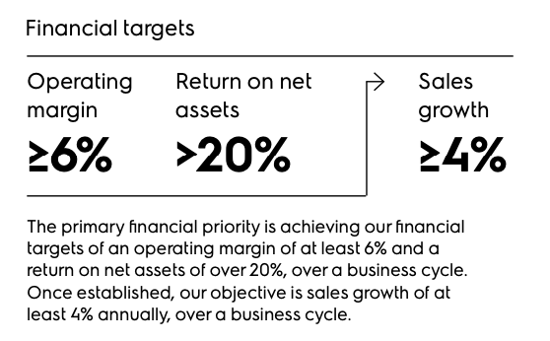****Exhibit 5:*** *Target for Profitable Growth* ***Exhibit 6:*** *Market Share*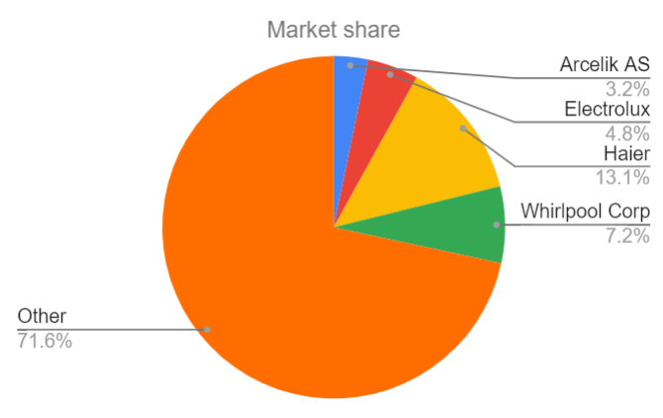

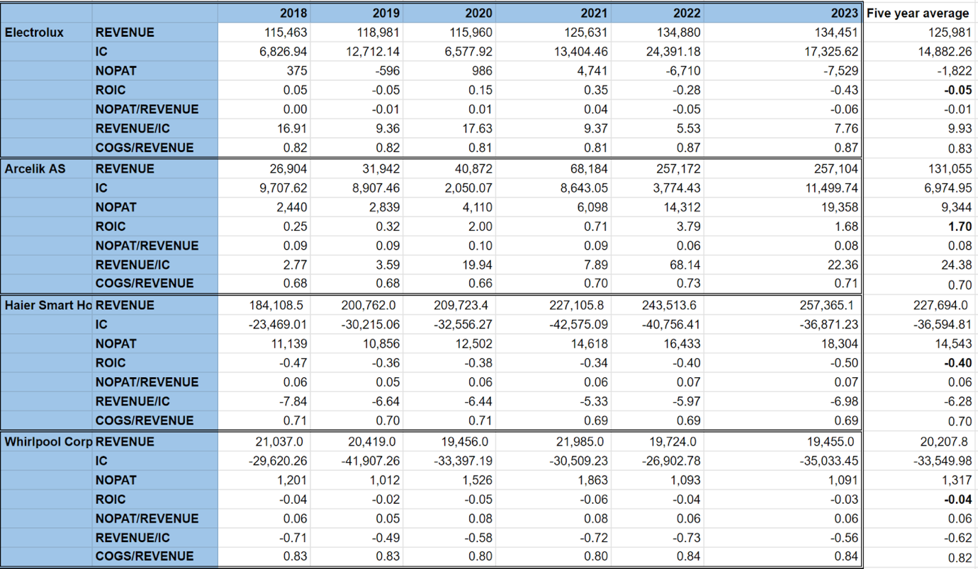

***Exhibit 7:*** *Peer Performance Comparison*

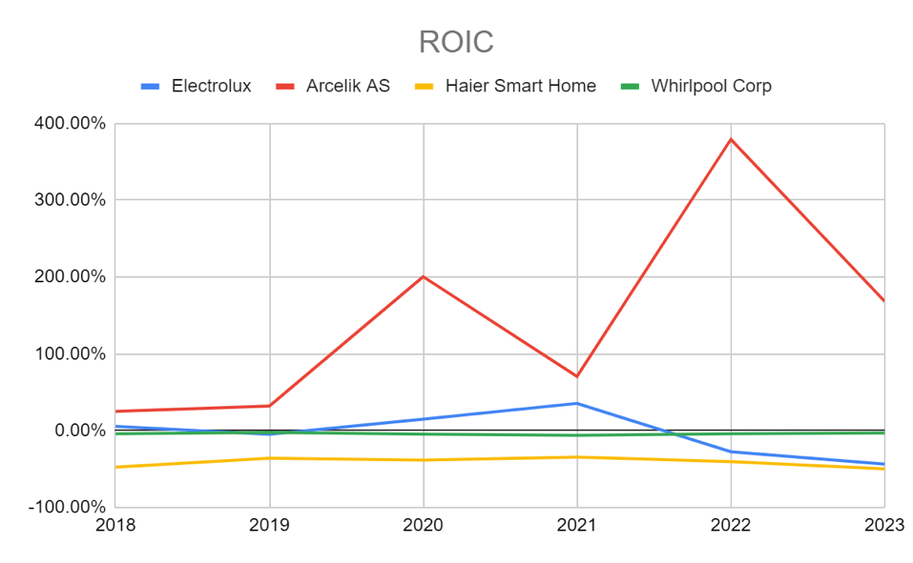

***Exhibit 8:*** *ROIC*

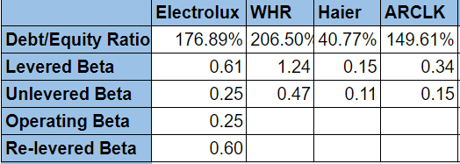

***Exhibit 9:*** *Beta* ***Exhibit 10:*** *Ratings and Coverage Ratios (*[*nyu.edu*](https://pages.stern.nyu.edu/~adamodar/New_Home_Page/datafile/ratings.html)*)*

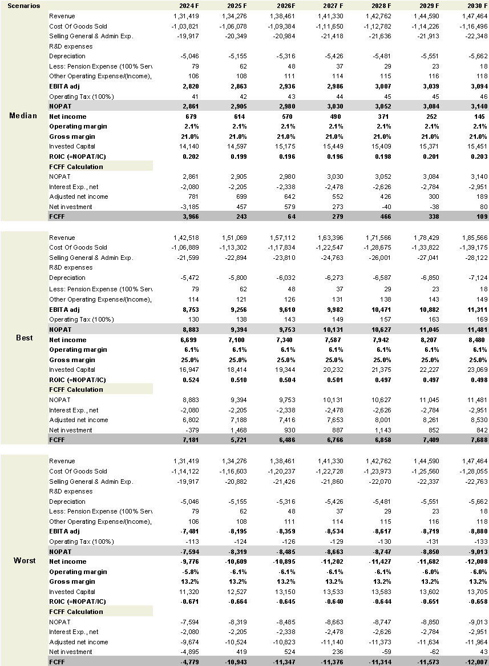

***Exhibit 11:*** *Key driver forecast and FCFF*

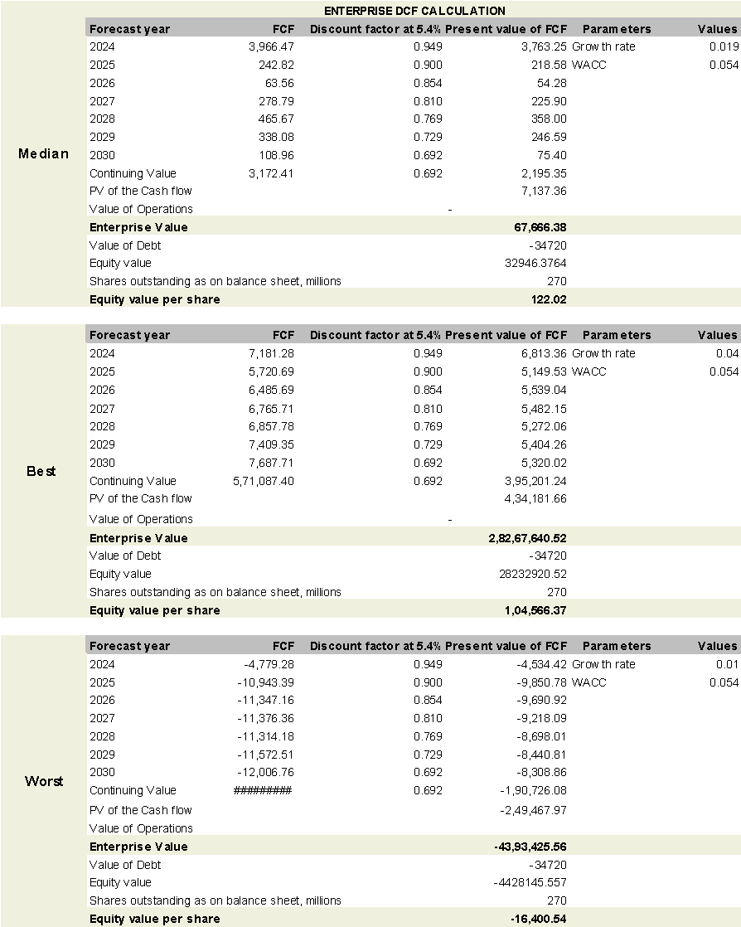

***Exhibit 12:*** *DCF Calculation and continuing values*

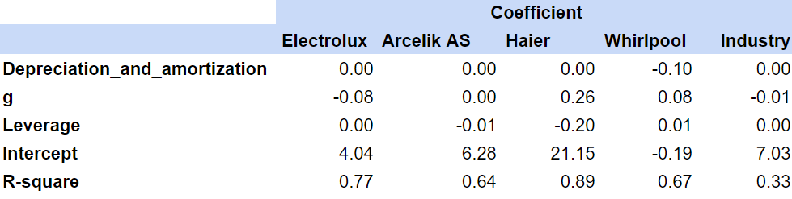

***Exhibit 13:*** *Regression coefficient results of the comparable firms and the industry*

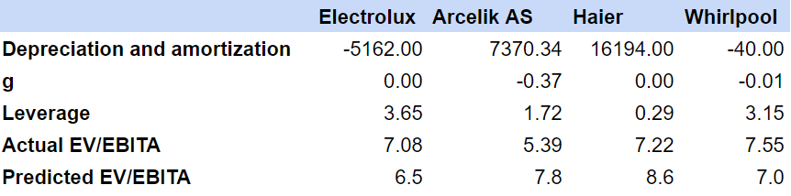

***Exhibit 14:*** *Predicted multiple results for each firm using industry coefficient*

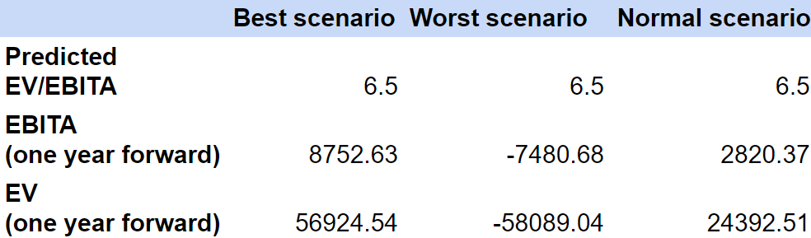

***Exhibit 15:*** *One-year forward EV using predicted EV/EBITA in three scenarios*

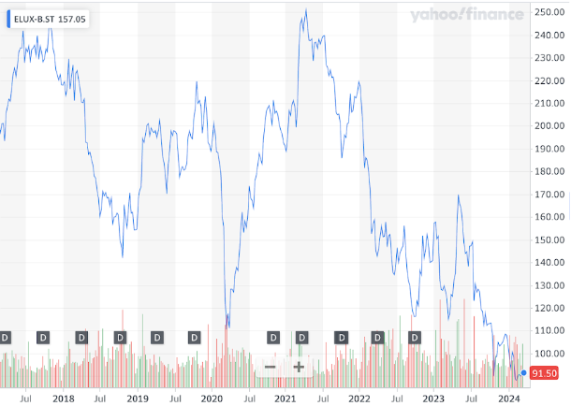

***Exhibit 16:*** *Share Price from 2018 to 2023 (in SEK)*